AQUI VAI O TÍTULO DO SEU ARTIGO EM INGLÊS

Meu nome nome
meu e-mail@usp.br

Abstract: Furnish here your paper abstract xxxxxx

Keywords: your paper keywords

- INTRODUCTION

Describe here your paper motivation and interest
.

- State-of-the-art (ou literature review) – use um deles apenas

Segue abaixo um texto de exempo do artigo do Beethoven….
Distributor is an important component in falling film simultaneous heat transfer and mass transfer process because it depends on how the liquid is distributed on the first horizontal tube. If a bad distribution happens on the first tube, the other tubes, below it, will also have a bad distribution, affecting the film thickness measurement such as it was studied by Narvaéz-Romo et al, (2014). The distributor has to wet all the surface of the first tube and its height should be appropriated.
In order to facilitate the understanding of the types of distributors analyzed, a set of schematics are shown in Figure 1 and the corresponding authors are listed in Table 1. In this part will be discussed the advantages and disadvantages of each one.
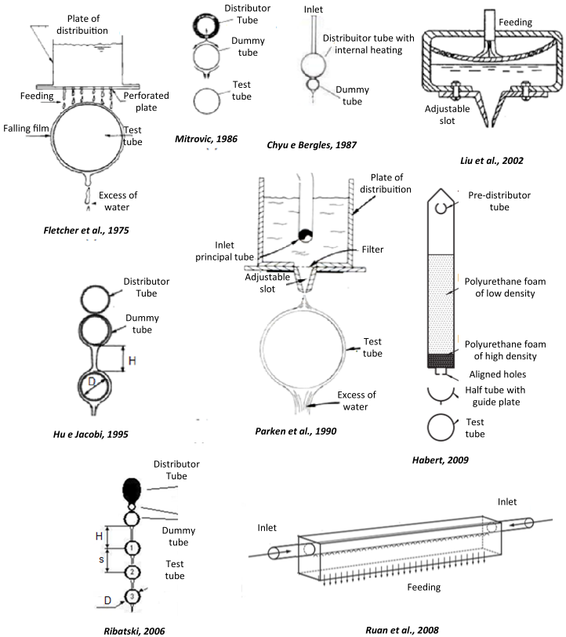
Figure 1 Schematic representation of the types of distributor in horizontal tubes falling film evaporation system

Table 1. Summary of the types of distributors using horizontal tubes
Author | Flow distributor
 | Characteristics
Fletcher et al., 1974 | Perforated plate in the bottom with a storage tank. | - | -
Mitrovic, 1986 | Perforated tube on the superior part. Holes diameter: 0.8mm  Separation: 3 mm; Length: 300 mm | 180 | 20-105
Chyu e Bergles, 1987 | Cylindrical tube with internal heating, which is able to keep the liquid in subcooled condition.  Distribution by overflow on the superior part of the tube. | 152 | 0.5-25.4
Parken et al., 1990 | Adjustable slot with filtering system. | 152 | 63
Liu et al., 2002 | Adjustable slot. | 130;200;300 | -
Ribatski, 2006 | Dummy tube to gurantee a homogeneous distribuiton. | - | 8.5-156
Ruan et al., 2008 | First part: Working fluid entering by both sides.  Tube made of PVC material – 61 holes of 3 mm diameter and 5 mm separation pitch.  Second part: Accumulative distributor using a box made of plexiglass with 60 holes of 1 mm diameter and 5 mm separation pitch. | 50-295 | 11-24-45
All of the distributors showed in Figure. 1 present common efforts to keep; (1) a low liquid injection velocity, and (2) a less disturbed liquid just before the distribution, as pointed out by Mitrovic (1986), Chyu and Bergles (1987), Hu and Jacobi (1995), and Ribatski (2006), which installed a dummy tube to achieve that. Habert´s (2009) configuration uses the loss pressure concept, obtaining low velocities in the distribution on the evaporator tube. Moreover, it uses a half tube with guide plate to help to the fluid orientation.
When the distribution system between Flecther et al, (1975) and Parken et al, (1990) are compared, the latter has advantages because it guarantees a thin film thickness, decreasing the thermal resistance and improving the heat transfer (Parken et al., 1990). Ruan et al. (2008) used a different configuration, which has two inlets to the distribution system, promoting the uniformity in the feeding. Then, they projected a second chamber of distribution avoiding the bad distribution due to the fluid ingress in opposite ways. In the Table 1, it is given the distribution specifications.

- YOUR STUDY

In this section it is described the general testing experimental setup. It is highlighted the importance of keeping a good liquid distribution over the test tube.

  - Subsection title

Aqui coloque o assunto dessa subseção…..

  - Other subsection

- CONCLUSIONS

Escreva aqui a conclusão do seu artigo ….

- ACKNOWLEDGEMENTS

The first author thanks the Coordenação de Aperfeiçoamento de Pessoal de Nível Superior (CAPES) for the personal financial support.

- REFERENCES

Coloque as referências em ordem alfabética, como no exemplo abaixo. Ao longo do texto, faça as devidas citações….

Chyu, M.C.; Bergles., 1987. An analytical and experimental study of falling film evaporation on a horizontal tube. Journal of Heat Transfer, Vol. 109. P. 983-990.
Fletcher, L.S.; Sernas, V. and Galowin, L.S., 1974. Evaporation from Thin Water Films on Horizontal Tubes. Ind. Eng. Chem., Process Des. Develop., Vol. 13, n. 59, p. 265-269.
Gonzalez G.J.M. and Jabardo, J. M. S.; Stoecker, W. F., 1992. Falling Film Ammonia Evaporators. Air Conditioning and Refrigeration Center. University of Illinois. Mechanical and Industrial Engineergin Dept. USA.

